Lab Assignment-II

Report

SG#1

Lema Kandula (16202668)

Venu Babu Kolla (16203564)

We have developed an application using three APIs, which will send an SMS to the number provided and also speaks out the weather details of the specified location.

The APIs which are been used:

1. Twilio REST API for sending SMS to the provided number
2. Open Weather API to get the Weather details
3. Google Text to Speech API for the romoC to speak out the weather details

The Weather details that are been sent through SMS:

1. Temperature in kelvin
2. Minimum temperature in kelvin
3. Maximum temperature in kelvin
4. Humidity
5. Description of the sky (whether it rains or its clear)

**Usage of APIs - Relevance with the Project:**

Our Project is based on providing Home Security which detects any suspicious or unusual activity, speaks out using Google Text to Speech API and informs the owner or user the particular activity through SMS using Twilio REST API.

Our romoC will speak out to the people the Weather conditions whenever they are going out of the house.

**Screen Shot for the SMS which is been sent to the provided number in UI**

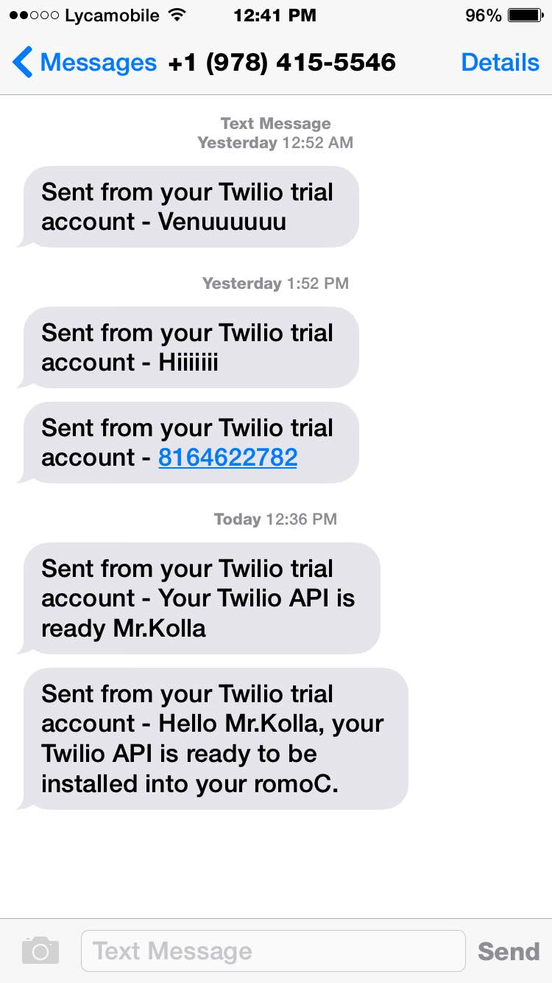

**Screen Shot of the UI**

